Unit #3 Scratch a programming language

Scratch is a visual programming language and online community targeted primarily at children. Using Scratch, users can create online projects and make them into anything by coding with simple blocks.

**Learning Objectives**

After completing this unit, students will be able to

* Know about Scratch
* Get familiar with stage
* Get familiar with sprite
* Get familiar with scripts
* Get familiar with costume
* Choose a sprite for project
* Use control which moves a character in scratch
* Create stories in sequence using scratch by inserting
  + Speech bubble
  + Thought bubble
  + Wait controls

# 1 Introduction

Scratch is a programming language that lets you create your own interactive stories, animations, games, music, and art. It is designed by the Kindergarden Lifelong Learning Group at MIT to introduce some basic programming concepts in a fun and interactive manner.

In Scratch, *sprites* (objects) are manipulated on the *stage* (background/backdrop) using various *scripts* (small program segments). Each sprite has its own set of scripts to control its behaviors and how it interacts with other sprites and events. Programming consists of snapping together individual blocks of preexisting actions to create a script. A program can be as simple as a single block or consist of multiple blocks stacked together that will run as a unit.

DO YOU KNOW?

Scratch is used in more than 150 different countries and available in more than 40 languages. To change languages in the Project Editor, click the globe at the top left corner in the menu bar.



.

Opening Scratch

Users can program in scratch online editor by creating an account and logging in at <https://scratch.mit.edu/> . The website also has a lot of tutorials, helping material and features top projects created by the users.

Alternatively you can download offline editor for scratch which is identical to the one available at the website. To open the downloaded editor on your computer follow these steps:

* Bring up Windows 10 start menu
* Type **scratch** in the search box of Windows 10 Start menu. Then in the program list, it will display the Scratch 2 offline editor. Click to open it

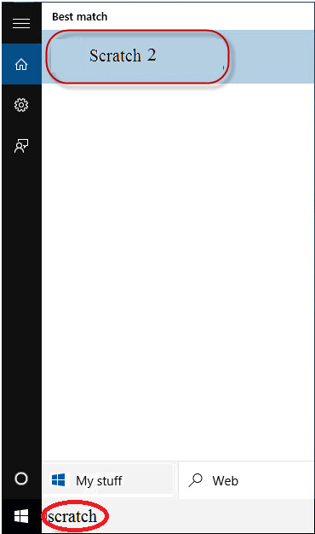

3.1 (a) open scratch offline editor

* Main screen of Scratch 2 offline editor will open.

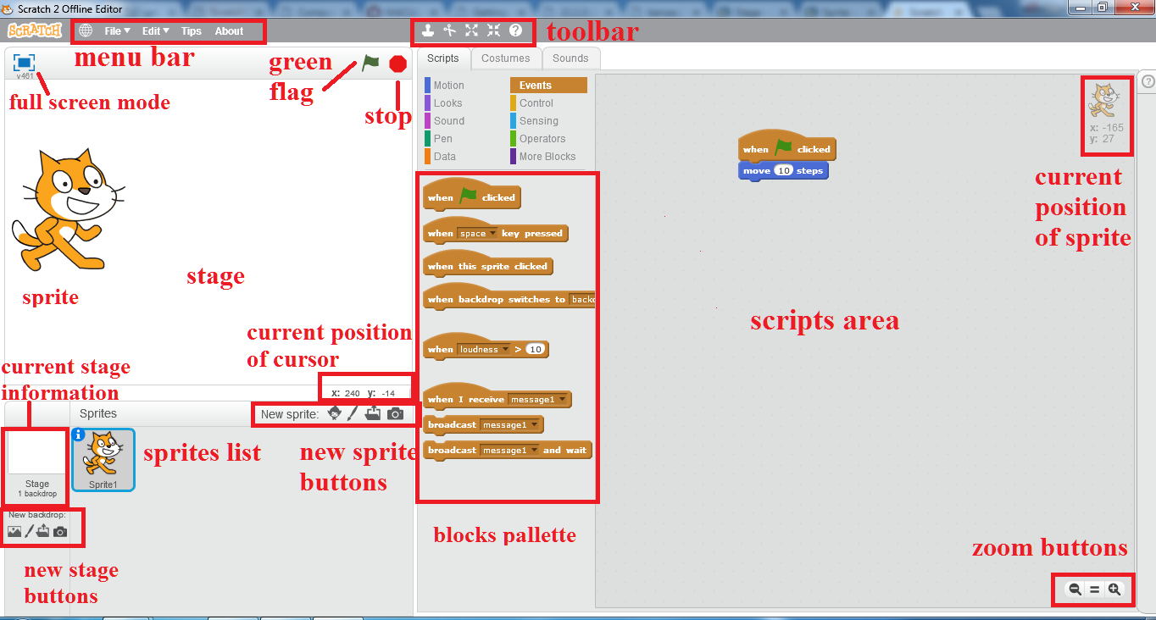

3.2 (b) Scratch main interface

DO YOU KNOW?

The Scratch Wiki is a collaboratively-written wiki available for free that provides information about the Scratch programming language and its website, history, and phenomena surrounding it..

.

* **Scripts**

A script is defined within the Scratch program as one or a set of blocks that begins with a *Hat Block*. Even a single block can qualify as a script. However, scripts are usually referred to as sets of blocks that consist of at least two blocks. A script is a collection or stack of [blocks](https://en.scratch-wiki.info/wiki/Blocks) that all interlock with one another. The blocks and their order are very important, as they determine how [sprites](https://en.scratch-wiki.info/wiki/Sprite) interact with each other and the [backdrop](https://en.scratch-wiki.info/wiki/Backdrops).

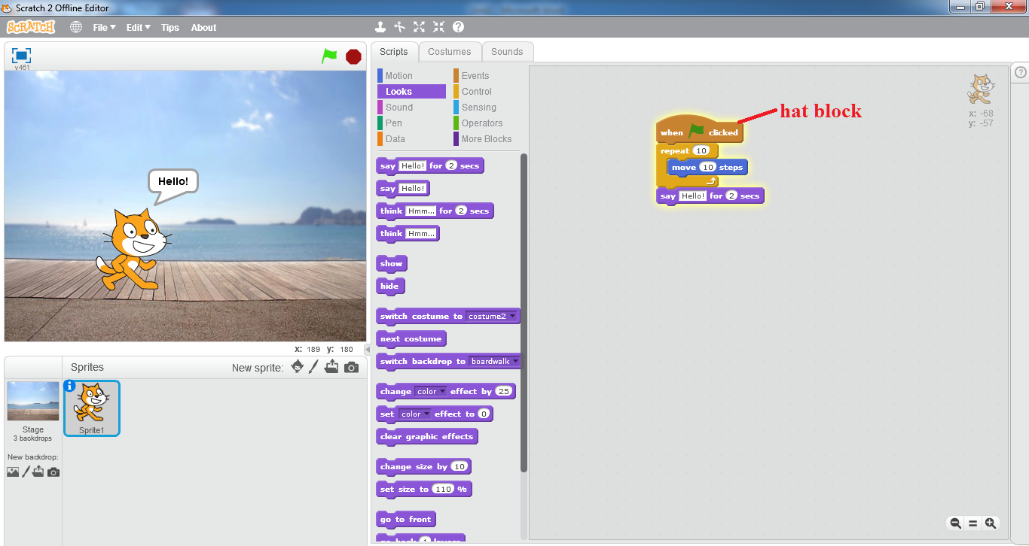

3.1 (c) an example script

* + **Block Shape**

Every block shape is designed so that it can do one or more of the following:

* + - Start a script

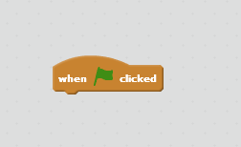

* + - Add to the end of a script

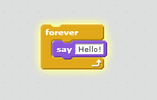

* + - End a script

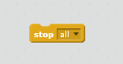

* + - Fit inside other blocks.

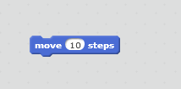

* + - Contain other blocks.

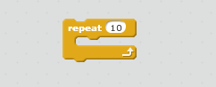

Because of that, blocks can be assembled to create a script like a jigsaw puzzle. This prevents syntax errors.

* + **Using Scripts**

Scripts are easy to work with. Some "rules" are as follows:

* + - To create a script, one simply has to drag blocks out of the [*Block Palette*](https://en.scratch-wiki.info/wiki/Block_Palette) and assemble them.
    - To assemble blocks, they must be dragged on, below, or inside another block. (Except for [Hat Blocks](https://en.scratch-wiki.info/wiki/Hat_Block).)
    - To disassemble blocks, they must be dragged apart.
    - To remove a script, drag it into any of the block palettes, or right-click the hat block and press delete to remove the whole script.
    - To start a single script just click on it.

Scripts can be edited in the scripts tab of every sprite and the [Stage](https://en.scratch-wiki.info/wiki/Stage).

* **Costumes**

A **costume** is one out of possibly many frames or alternate appearances of a [sprite](https://en.scratch-wiki.info/wiki/Sprite). Sprites can change their look to any of its costumes. They can be named, edited, created, and deleted, but every sprite must have at least one costume. One of the most common uses of costumes is to make an animation for a game or other project.

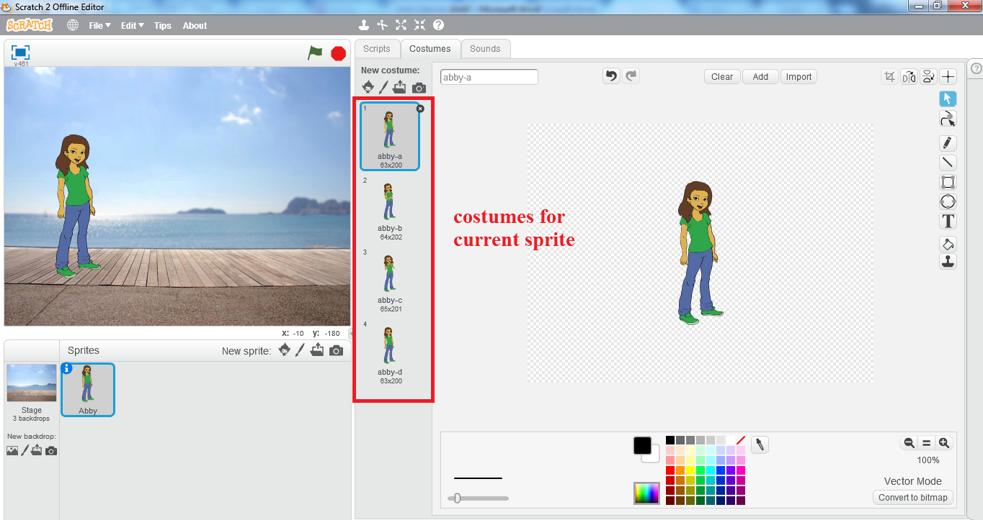

3.3 (d) costumes

While sprites contain costumes, the [Stage](https://en.scratch-wiki.info/wiki/Stage) contains backdrops. They can be used in the same way.

* **Sprite**

Sprites, either user created, uploaded, or found in the [sprites library](https://en.scratch-wiki.info/wiki/Libraries#Sprites_Library), are the [objects](https://en.scratch-wiki.info/wiki/Object-Oriented_Programming) that perform actions in a [project](https://en.scratch-wiki.info/wiki/Project). While the [Stage](https://en.scratch-wiki.info/wiki/Stage) can also be programmed in a project, most projects have at least one sprite as well because only sprites can move.

* + **Creating a sprite**

The bar above the sprite list has four buttons for creating sprites. They are:

* + - The [Giga](https://en.scratch-wiki.info/wiki/Giga) button allows you to choose a sprite from the [library](https://en.scratch-wiki.info/wiki/Libraries#Sprites_Library).
    - The paintbrush button creates a blank sprite with an empty costume.
    - The folder button allows you to upload a sprite from your computer.
    - The camera button allows you to take a picture and uses that image as the sprite.

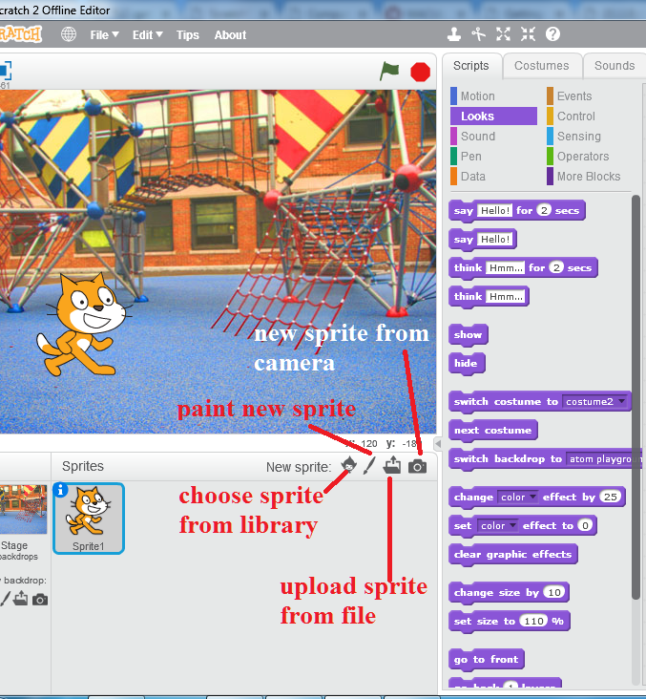**3.1 (e) create new sprite**

When a sprite is created, it will place that sprite at a random location on the Stage, usually around the center, and open the sprite in the tab you're currently viewing.



Try It Yourself!

* Click on *paint new sprite* button
* Scratch paint editor will open up
* Using the ellipse tool on the left side draw an ellipse
* Use the *fill with color* tool to fill it with red color
* The red ball sprite will appear on the stage and

its thumbnail will appear in the sprites list with

the name *Sprite 1*

* + **Scripts tab**

Each sprite in a Scratch project has an area for [scripts](https://en.scratch-wiki.info/wiki/Script), called the [scripts area](https://en.scratch-wiki.info/wiki/Scripts_Area). Users can give instructions to a sprite (such as telling the sprite to move) by snapping [blocks](https://en.scratch-wiki.info/wiki/Blocks) together in the scripts area. Clicking on the blocks in the script area will cause the sprite to react based on the function of the blocks clicked. Clicking on a sprite's thumbnail in the sprite pane will bring up the script area of that sprite.

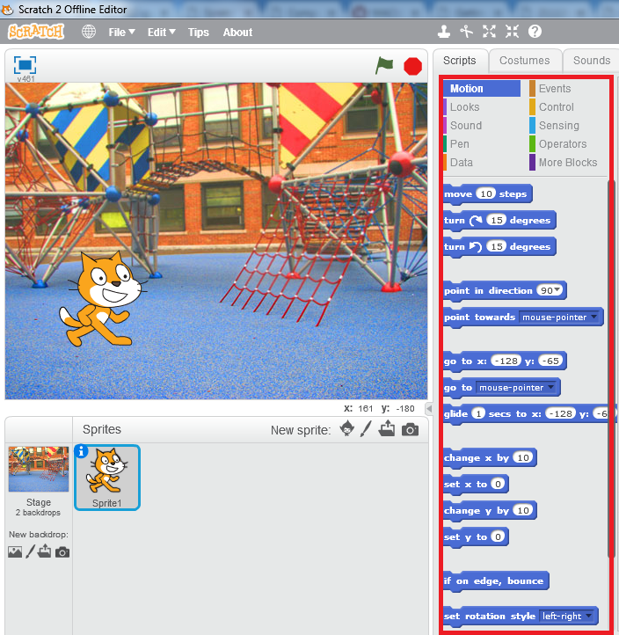

3.1 (f) scripts tab for sprite

* + **Costumes tab**

The look of a sprite can also be changed by using [costumes](https://en.scratch-wiki.info/wiki/Costume). The current costume of a sprite can be changed by clicking on the *costumes* tab and clicking on the desired costume of choice, or by using [Looks](https://en.scratch-wiki.info/wiki/Looks) blocks to select the sprite's costume. New costumes for the sprite can be imported, created, and edited in the Scratch [Paint Editor](https://en.scratch-wiki.info/wiki/Paint_Editor).

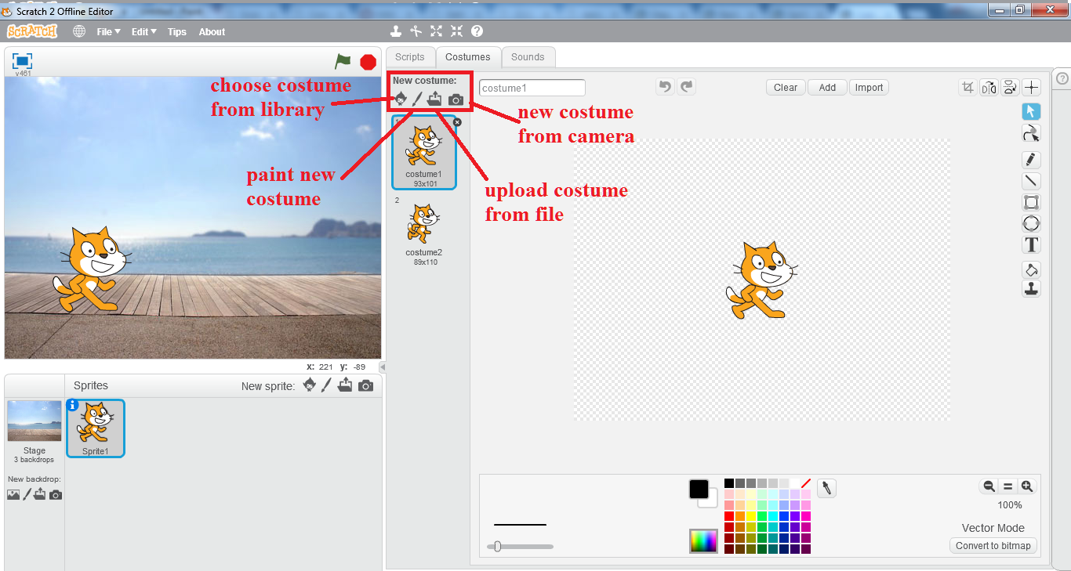

3.1 (g) costumes tab for sprite

* + **Sounds tab**

Some sprites additionally have at least one [sound](https://en.scratch-wiki.info/wiki/Sound). Unlike costumes, sounds are an optional field, so you can have a sprite with no sounds. The sounds tab allows you to add, delete, and [edit](https://en.scratch-wiki.info/wiki/Sound_Editor) sounds. Sounds can be played in the sound editor or with blocks that play a specific sound.



Try It Yourself!

* In the *blocks palette* select *Sound*
* Click and drag  block

to the *scripts area*

* Click on the play sound block in the *scripts area*
* You will be able to listen to the meow sound.

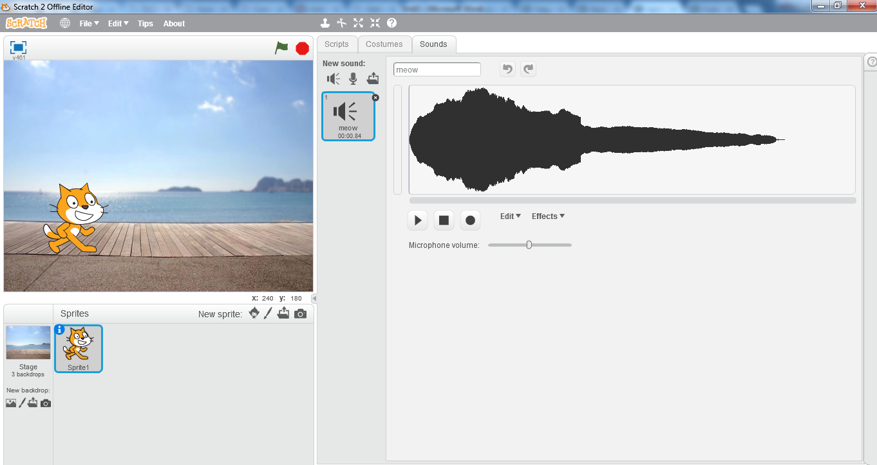

3.1 (h) sounds tab for sprite

* **Stage**

The **Stage** is the term for the background of the [project](https://en.scratch-wiki.info/wiki/Project), but it can have [scripts](https://en.scratch-wiki.info/wiki/Script), [backdrops](https://en.scratch-wiki.info/wiki/Backdrops) (costumes), and [sounds](https://en.scratch-wiki.info/wiki/Sound). It does not have all functionalities as that of a sprite such as motion [blocks](https://en.scratch-wiki.info/wiki/Blocks). No sprites can move behind the Stage; the Stage is always at the back layer.

* + **Scripts tab**

The Stage field has a scripts tab that can be used in the same way as in a sprite, with the following exceptions:

* + - The [motion](https://en.scratch-wiki.info/wiki/Motion_Blocks), say, think, [Show](https://en.scratch-wiki.info/wiki/Show_(block)), [Hide](https://en.scratch-wiki.info/wiki/Hide_(block)), [costume](https://en.scratch-wiki.info/wiki/Costume) blocks cannot be used.
    - The [Switch Backdrop to () and Wait](https://en.scratch-wiki.info/wiki/Switch_Backdrop_to_()_and_Wait_(block)), [Next Backdrop](https://en.scratch-wiki.info/wiki/Next_Backdrop_(block)), and [Backdrop #](https://en.scratch-wiki.info/wiki/Backdrop_Number_(block)) blocks are only for the Stage.

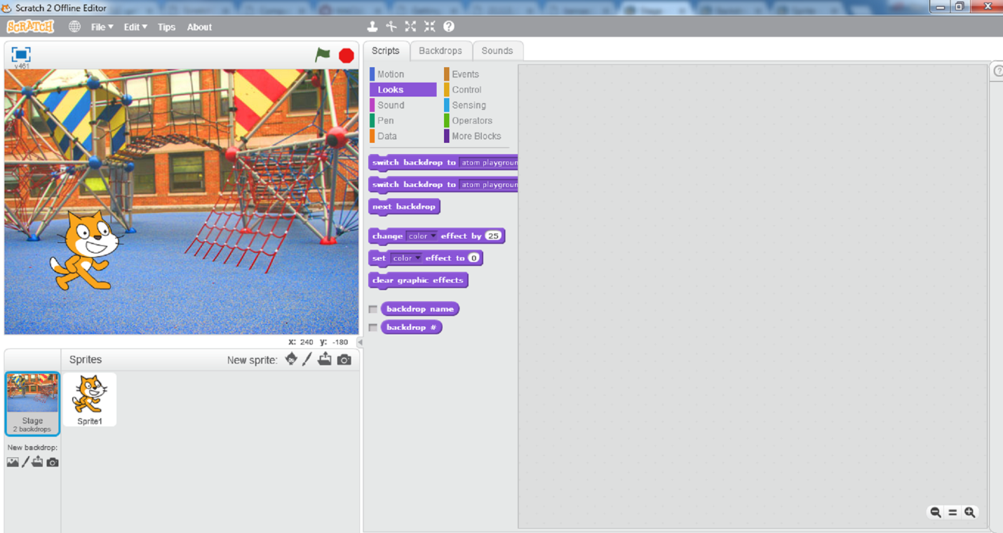

3.1 (i) stage scripts

* + **Backdrops tab**

There is also a **backdrops tab** that can be used to add, delete, and edit backdrops. This field is required, and the last remaining backdrop cannot be deleted. The dimensions are always 480x360. Transparent areas automatically become white in the project.

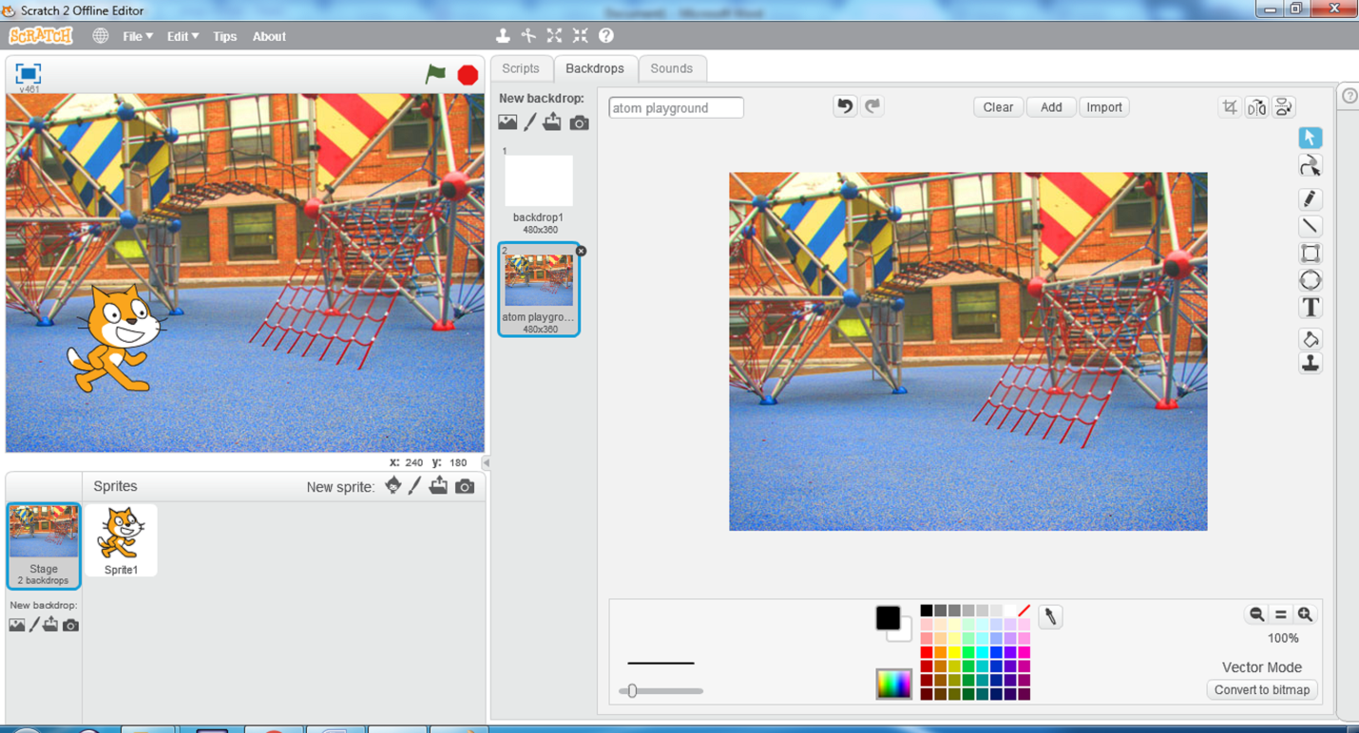

3.1 (j) stage backdrops

* + **Sounds tab**

The optional sounds tab is identical to the sounds tab in sprites.

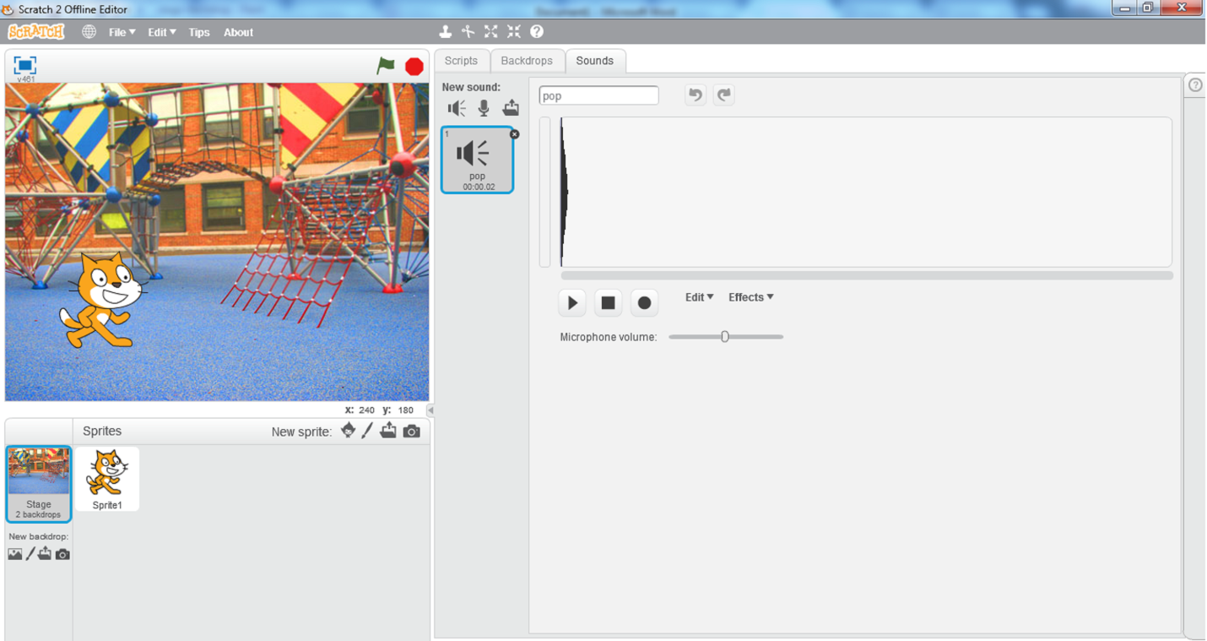**3.1 (k) stage sounds**

* + **Stage sizes**

The stage can be of 3 different sizes:

* + - **Regular**

Normal mode; the Stage is 480x360 pixels.

* + - **Small Stage Layout**

The stage is half the size with a resolution of 240x180 pixels; this is useful for having more room in the scripts area. This option can be accessed through the *Edit* option.

* + - **Full-screen mode**

It fits the stage to your computer’s current resolution.

# 2 Animation

**Selecting a new sprite**

* + Open scratch offline editor
  + By default *cat* sprite is selected
  + Right-click on the cat sprite thumbnail in the sprite list area and click on *delete*

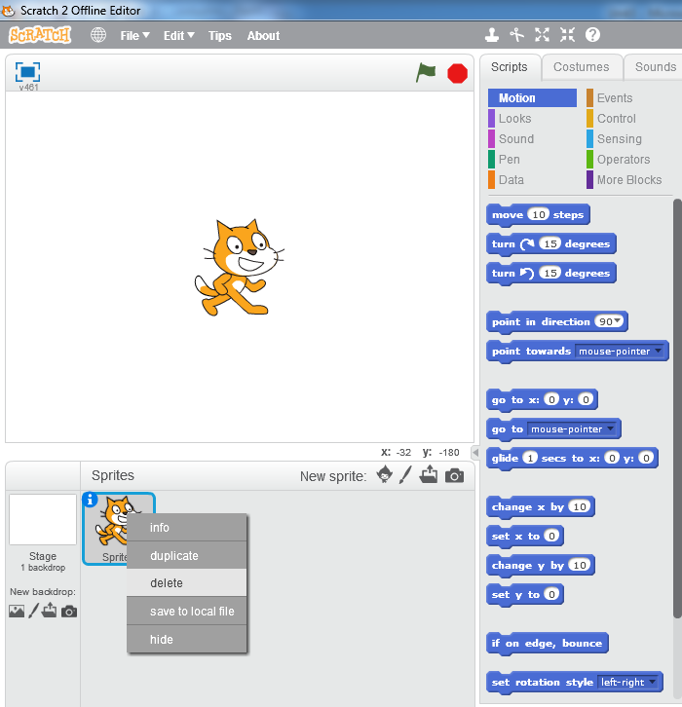

**3.2 (a) deleting the sprite**

* Click on the *Giga* button in the *New sprite* area to select a new sprite from the library
* Sprite library will open up.

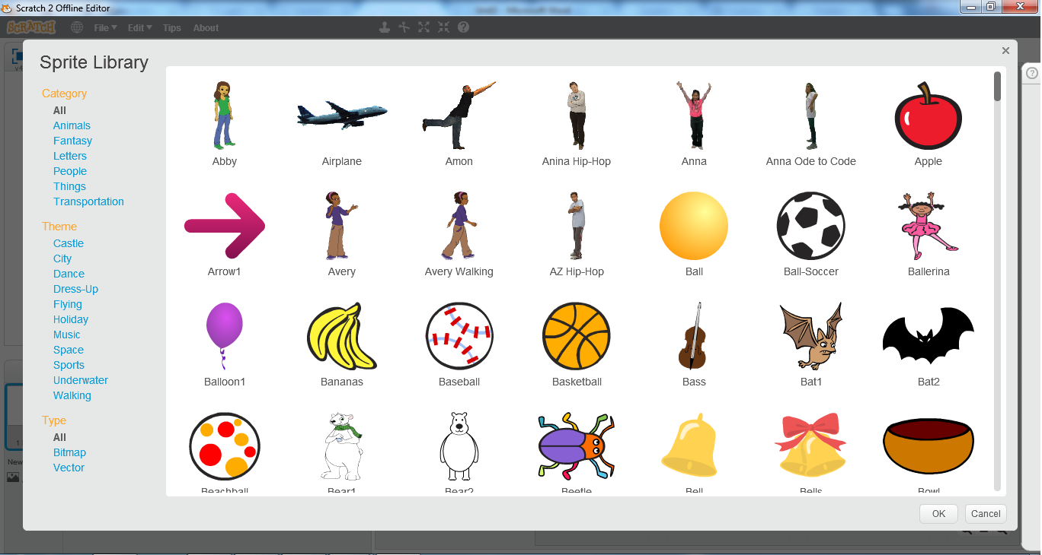

**3.2 (b) sprite library**

* Select the first sprite *Abby* and click ok
* Sprite will be placed on the stage at a random point and its thumbnail will appear in the sprite list.

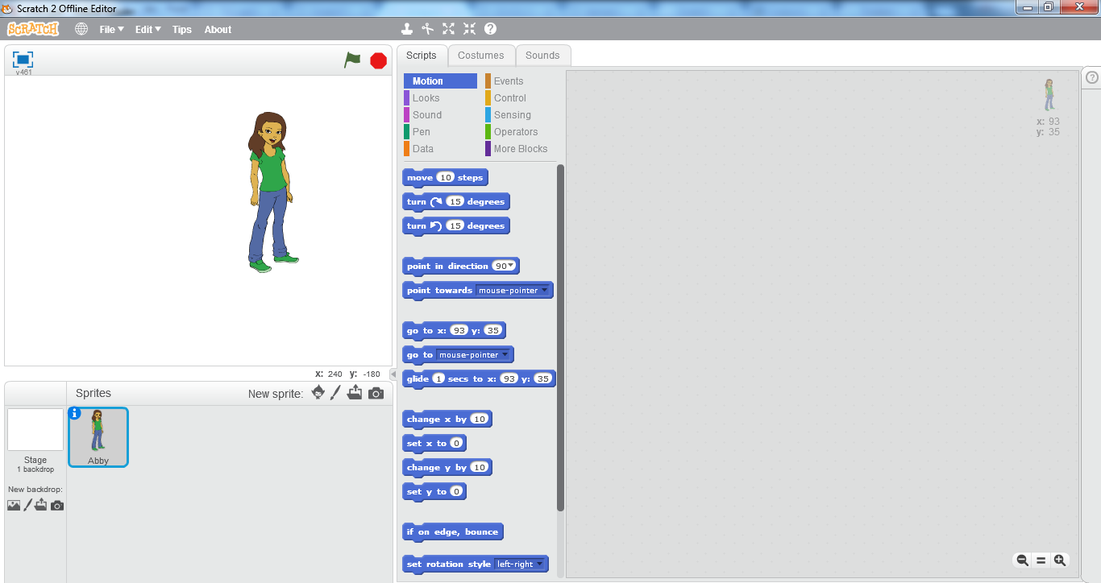

**3.2 (c) Abby sprite**

**Moving the Sprite**

* Drag and place *Abby* on the left most corner of the stage
* From the *Blocks Palette* area drag “*move 10 steps”* to the *scripts area.*
* The 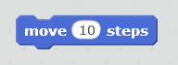 block moves the sprite 10 steps towards the right side of the stage.

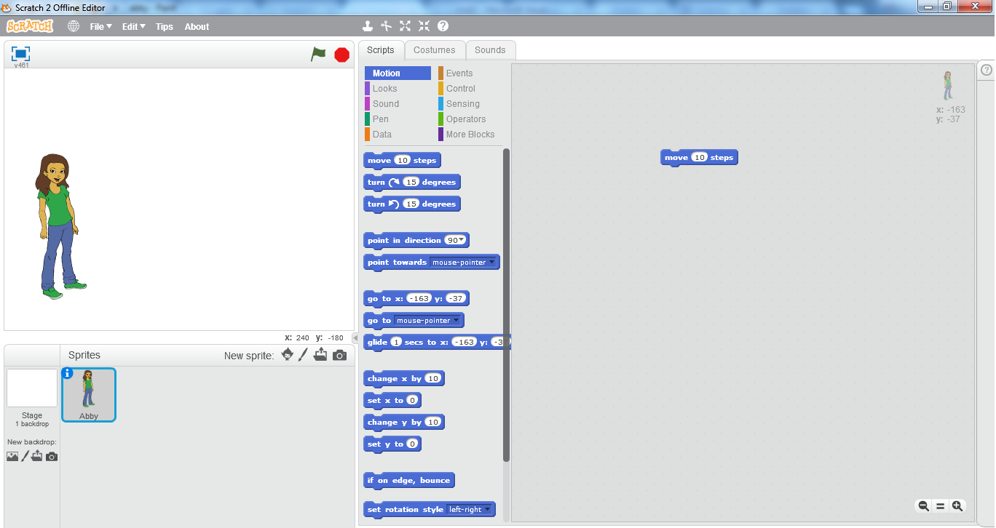

**3.2 (d) moving the sprite**

* Click on the move block in the scripts area
* You can see the sprite *Abby* moving to the right side of the stage
* Keep clicking on the move block until the sprite reaches the right end of the stage.

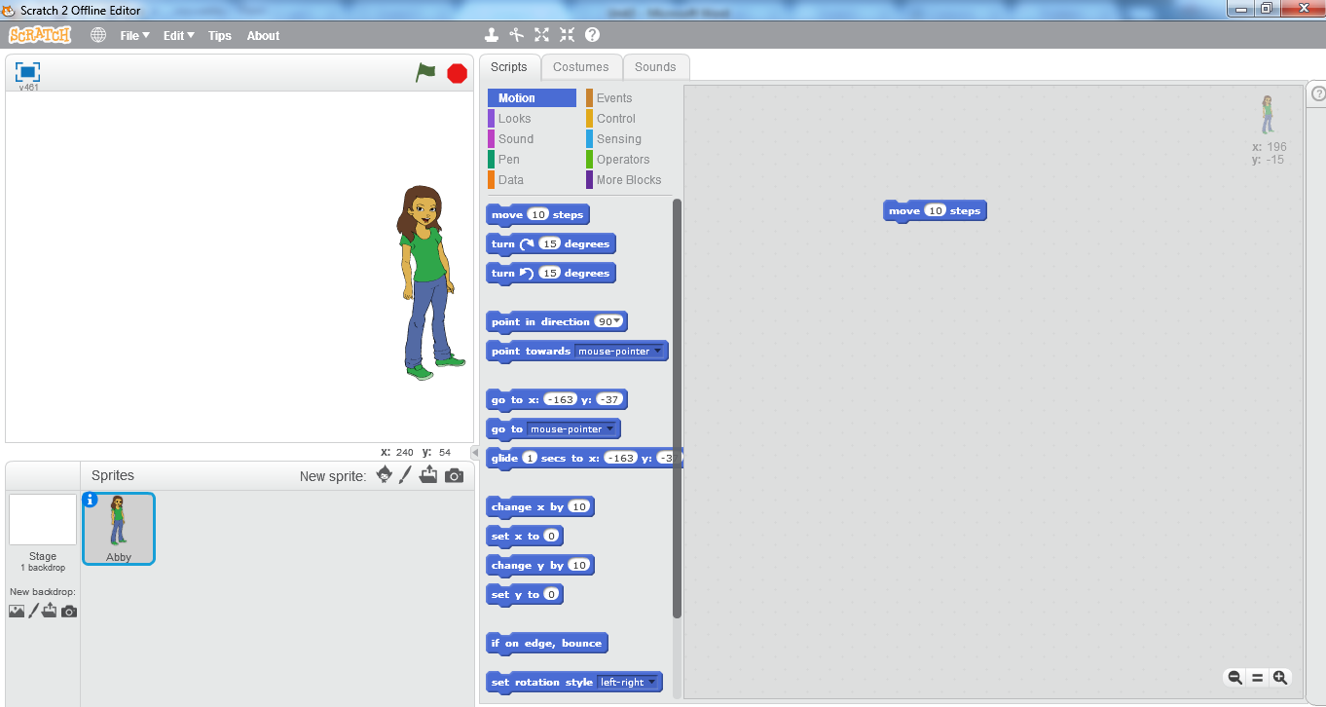

**3.2 (e) moving the sprite**

Try It Yourself!

* You can also change the number of steps your

sprite will move

* Write 50 in place of 10 steps
* Click on the move block and see the difference

in movement of sprite

* Write 100 and click on the move block



# 3 Conversation

* Click and Drag the sprite *Abby* to the left most side of the stage
* Click on the *Giga* button to open sprite library
* Choose another sprite *Avery*

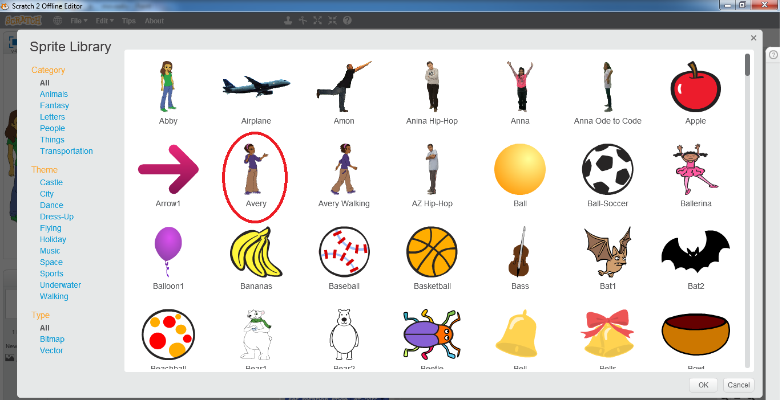

**3.3 (a) sprite library**

* It will be placed randomly on the stage and its thumbnail will appear in the sprites list

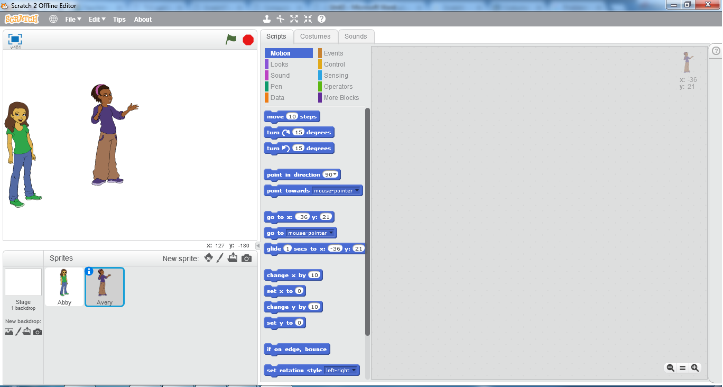

**3.3 (b) creating another sprite**

* Click and drag *Avery* to the right most side of the stage
* Click on the *costumes* tab
* In the scratch paint editor, click on the *Flip left-right* button in the top left corner of the screen

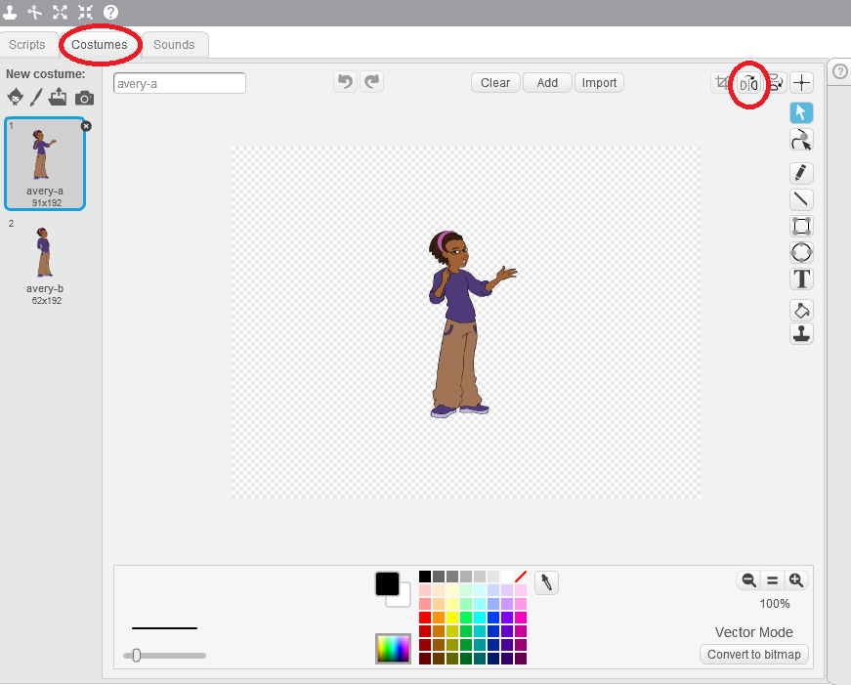

**3.3 (c) Avery costumes**

* By clicking on this button, the sprite *Avery’s* direction will change to the left side instead of right side

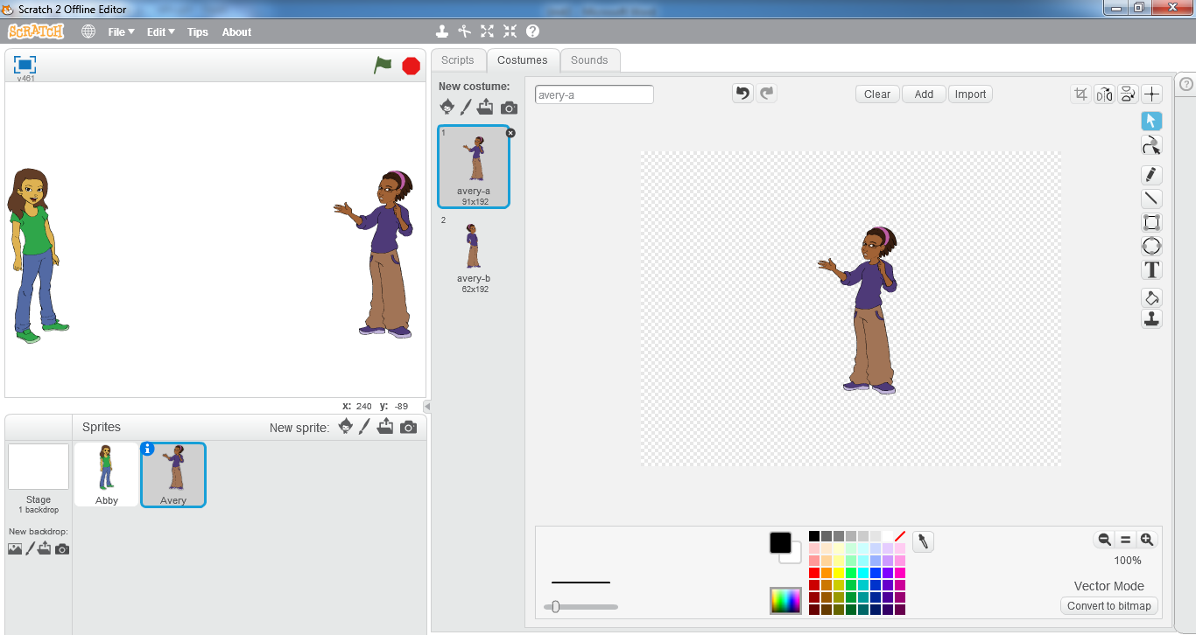

**3.3 (d) flip left-right**

**Using Speech Bubble**

* Click on *Scripts*
* Click on *Events*
* Click and drag the hat block  to the scripts area
*  block triggers the scripts written below it when user clicks on the green flag button.
* Click on *Looks*
* Click and drag the block  to the scripts area
* By using the  block, the sprite will say hello for 2 seconds and after that the speech bubble will disappear.
* Drag the block  towards the below side of the hat block until you see the below area of hat block highlighted.
* Release the mouse at that point. Both blocks should be merged together like this 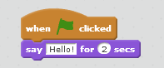
* Now click on the flag button
* You can see the sprite *Avery* saying Hello to the sprite *Abby*

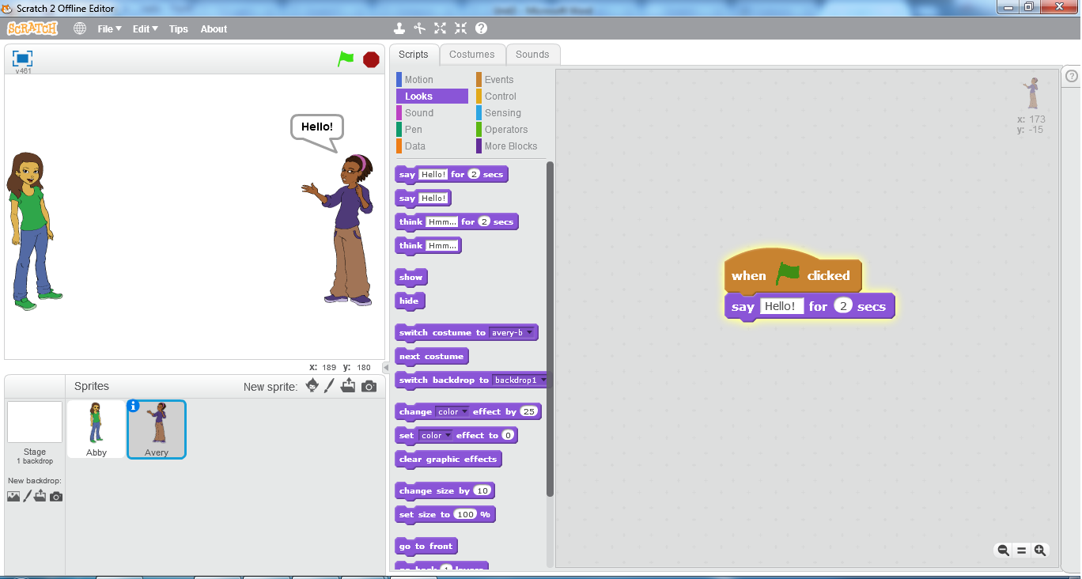**3.3 (e) sprite Avery saying hello**

Try It Yourself!

* You can also change the message that you want

your sprite to speak

* Click in the area where *Hello* is written in the *say*

block

* Write “*hello my friend*”
* Click on the *say* block
* You can see you sprite speaking the new message
* Write 5 in place of 2 secs and then click on the *say*

block



**Using Thought Bubble**

* Click on  block and drag it back into the *blocks pallete* area.
* Click on  block and drag it into the *scripts area*
* By using the  block, the sprite will think *hmm…* for 2 seconds and after that the thought bubble will disappear.
* Drag it below the *hat block* until you see the below part of the hat block highlighted and then attach it with the hat block. 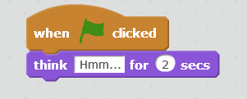
* Now click on the green flag button

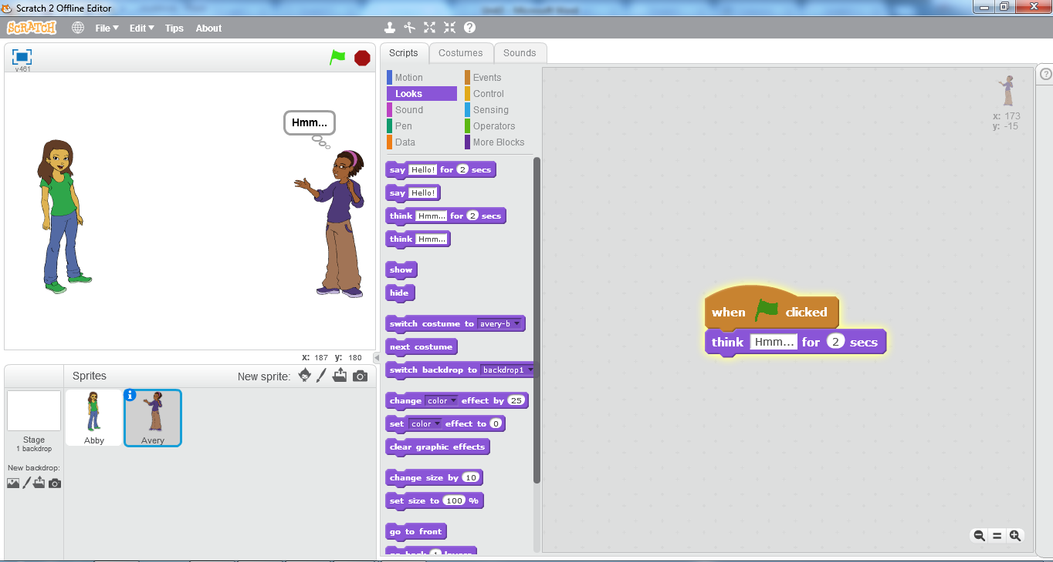

**3.3 (f) sprite Avery thinking**

* You can see the sprite *Avery* thinking *hmm…*

DO YOU KNOW?

You can also use 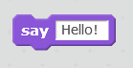 and 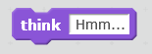 blocks instead of the ones we have used above. This will display the say and thought bubbles until you click on the *stop* button.



.

**Using Wait Controls**

* In the *sprites list* area click on the sprite *Abby* thumbnail.
* Click and drag  block to the *scripts area* and attach it with the  block.

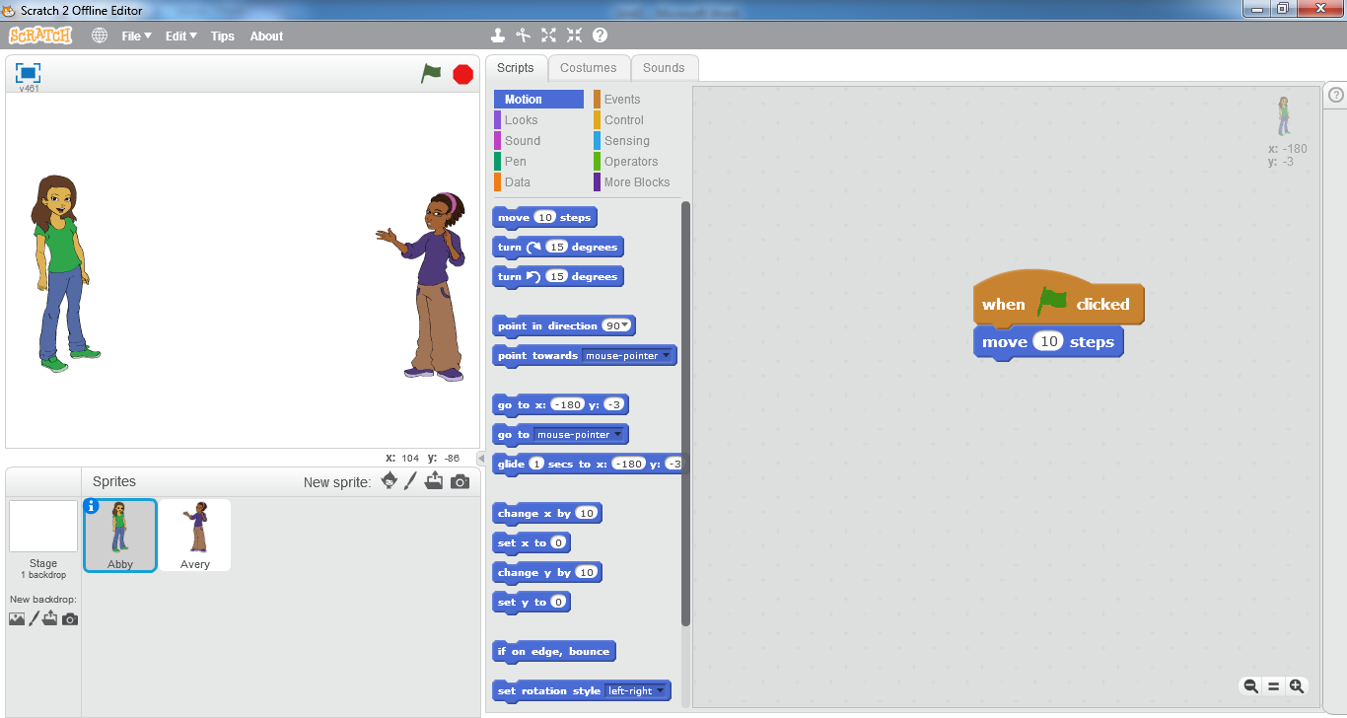

**3.3 (g) sprite Abby script**

* Click on *Looks*
* Click and drag  to the *scripts area* and attach it below the *move* block 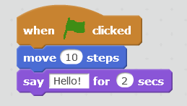
* Click on sprite *Avery* thumbnail in the *sprite list* area
* Click and drag all script blocks from the s*cripts area* except the *hat block*
* Click and drag  block from the *blocks palette* to the *scripts area* and attach it below the *hat* block 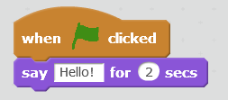
* Click on the green flag button

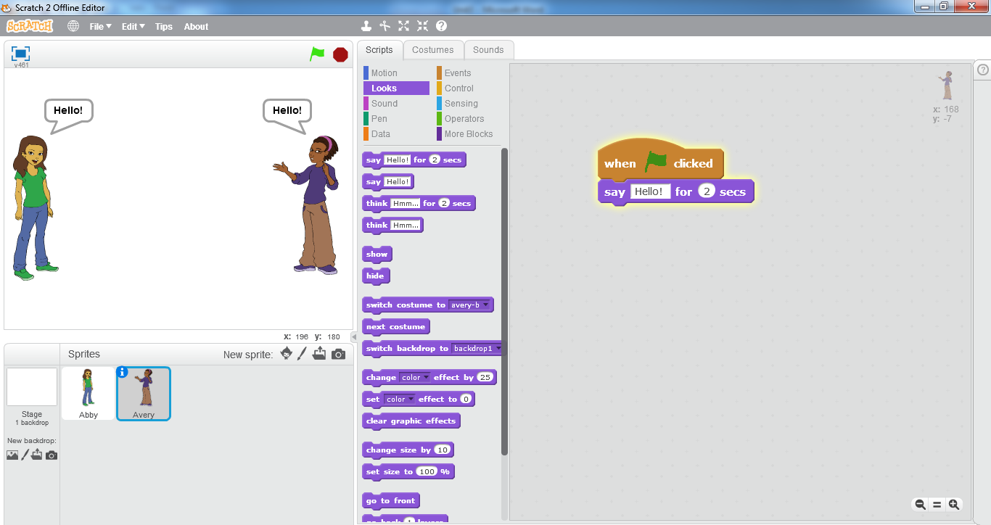

**3.3 (h) Both sprites saying hello**

You can see that scripts of both sprites are being played simultaneously and both are saying *hello* at the same time.

* Now in the *blocks* *palette* of sprite *Avery,* Click on *Control*
* Click and drag  from the *blocks palette* to the *scripts area* and Edit the wait block by writing 2 in place of 1



* Attach it between the hat block and the *hello* block.

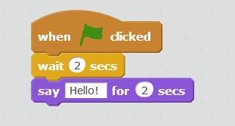

* Click on the green flag button. You can see the scripts of both sprites being played on the stage

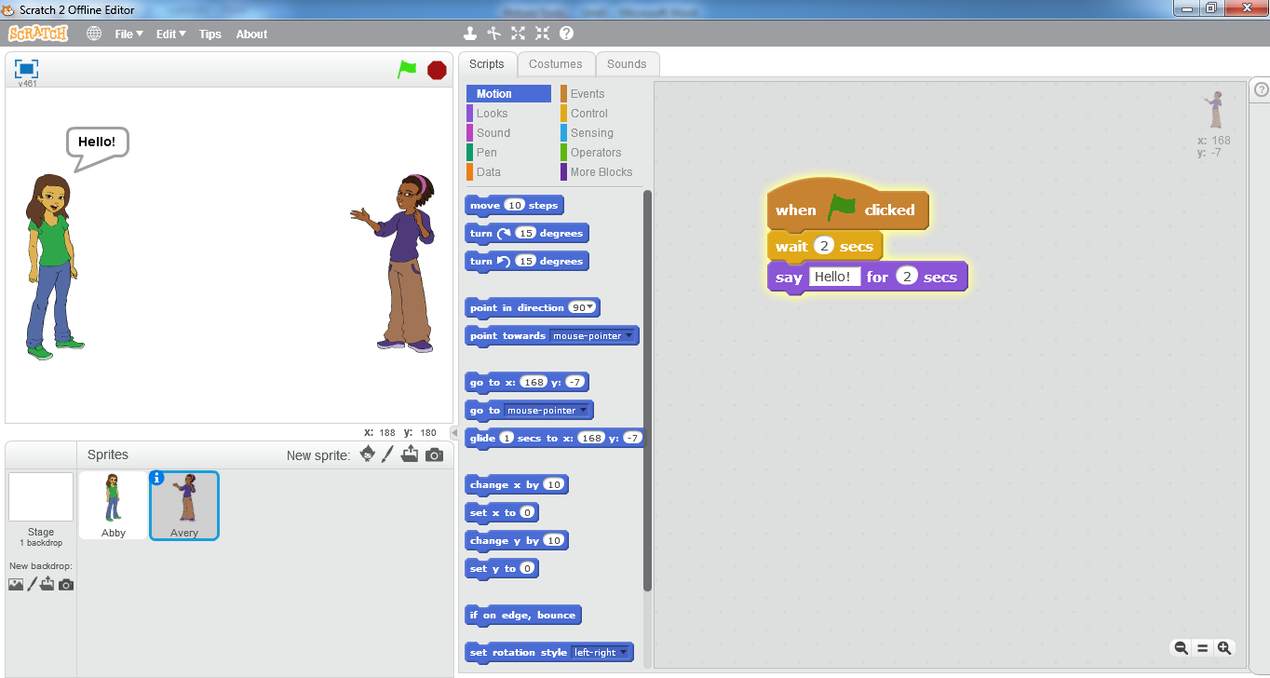

**3.3 (i) Sprite Abby saying hello**

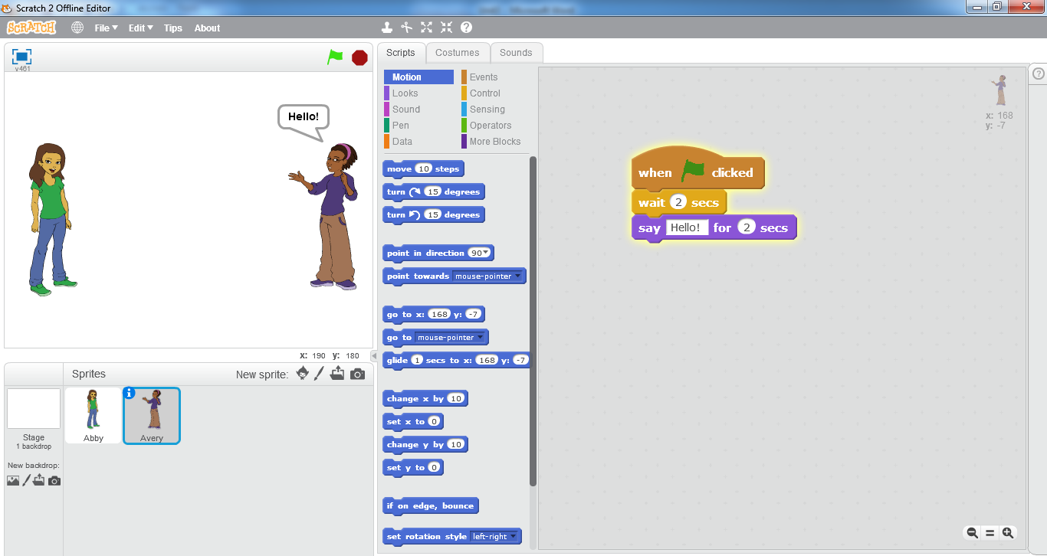

**3.3 (j) sprite Avery saying hello**

* You can see that first the sprite *Abby* will move towards the sprite *Avery* and then it will say *hello.* After that the sprite *Avery* will also say *hello* in return. The difference in the timings of saying *hello* from both sprites is caused due to the use of *wait* block. The **wait block**causes a delay of specified seconds before playing the script written below the wait block.

SUMMARY

* **Scratch** is a programming language that lets you create your own interactive stories, animations, games, music, and art.
* A **script** is defined within the Scratch program as one or a set of blocks that begins with a *Hat Block.*
* A **costume** is one out of possibly many frames or alternate appearances of a sprite.
* While sprites contain costumes, the Stage contains backdrops.
* **Sprites**, either user created, uploaded, or found in the sprites library, are the objects that perform actions in a project.
* Each sprite in a Scratch project has an area for scripts, called the **scripts area**.
* Unlike costumes, sounds are an optional field, so you can have a sprite with no sounds.
* The **Stage** is the term for the background of the project, but it can have scripts, backdrops (costumes), and sounds.
* Click on the *Giga* button in the *New sprite* area to select a new sprite from the library.
* By default *cat* sprite is selected in Scratch editor.
* The  block moves the sprite 10 steps towards the right side of the stage.
* By clicking on the flip left-right button the sprite changes it direction.
*  block triggers the scripts written below it when user clicks on the green flag button.
* By using the  block, the sprite will say hello for 2 seconds and after that the speech bubble will disappear.
* By using the  block, the sprite will think *hmm…* for 2 seconds and after that the thought bubble will disappear.
* The *wait block* causes a delay of specified seconds before playing the script written below the wait block.

EXERCISE

**Q.1 Tick the right choice**

1. In Scratch, spritesare manipulated on the stageusing various*_______*

a) scripts b) programs c) blocks d) codes

1. A script is defined within the Scratch program as one or a set of blocks that begins with a *_____________*
2. Move block b) think block c)hat block d)forever block
3. To create a script, one simply has to drag blocks out of the *___________* and assemble them.
4. Scripts area b) blocks palette c) stage d) tool bar
5. A **_________** is one out of possibly many frames or alternate appearances of a sprite
6. Stage b) sprite c)backdrop d) costume
7. _________ either user created, uploaded, or found in the sprites library, are the objects that perform actions in a project.
8. Stage b) sprites c) costumes d) backdrops
9. The ____________ button creates a blank sprite with an empty costume.
10. Paintbrush b) giga c)camera d) folder
11. Each sprite in a Scratch project has an area for scripts, called the _____________
12. Scripts palette b) blocks palette c)scripts area d) blocks area
13. The **_________** is the term for the background of the project, but it can have scripts, backdrops (costumes), and sounds.
14. Background b)stage c) backdrop d) costume
15. The Switch Backdrop to () and Wait, Next Backdrop, and Backdrop # blocks are only for the __________
16. Abby Sprite b)stage c) cat sprite d) new backdrop
17. The dimensions of stage are always __________.
18. 480 x 360 b)480 x 480 c) 360 x 360 d) 400 x 360
19. The stage can be of _____ different sizes
20. 2 b)3 c)4 d)5
21. By default ________ sprite is selected in scratch editor
22. Abby b)cat c) Avery d) Anna
23. The *______* blockcauses a delay of specified seconds before playing the script written below it.
24. Move b) think c)say d)wait

1. __________ layout is useful for having more room in the scripts area.
2. Regular stage b) full-screen stage c) small-stage d) large stage
3. The Stage is always at the ________ layer.
4. Front b) middle c) back d)centre

**Q.2 Fill in the blanks**

1) In Scratch, spritesare manipulated on the *_________* using various *__________*

2) ___________ consists of snapping together individual blocks of preexisting actions to create a script

3) The ________________ provides information about the Scratch programming language and its website, history, and phenomena surrounding it.

4) Scripts are usually referred to as sets of blocks that consist of at least _________ blocks

5) To create a script, one simply has to drag blocks out of the *__________________* and assemble them

6) One of the most common uses of __________ is to make an animation for a game or other project.

7) The _________ button allows you to choose a sprite from the library.

8) In _____________ layout the stage is half the size with a resolution of 240x180 pixels

9) By clicking __________________ button the direction of sprite will change from left side to right side

10) The **____________** blockcauses a delay of specified seconds before playing the script written below it.

**Q.3 Define the following**

1)Scratch 2) Scratch Wiki 3) Script 4) Costume 5)Sprite 6) Stage

**Q.4 Differentiate between the following**

1) Stage and Sprite 2) Costume and backdrops 3) sprite and costume

4) Regular and small-stage layout

**Q.5 Give short answers to the following questions**

1)What is scratch? How is programming done in scratch?

2) what are the steps for opening Scratch?

3) What are the different shapes of blocks available?

4) What are the rules for using scripts?

5) What are the four buttons for creating new sprite?

6) Explain scripts tab for stage

7) What are the available stage sizes?

8) Write down steps for moving a sprite

9) Write down steps for a sprite using though bubble for 2 seconds

10)Write down steps for painting a new sprite in scratch editor

**Q.6 Match the columns A and B and write matching pairs in column C.**

|  |  |  |
| --- | --- | --- |
| Column A | Column B | Column C |
| 1. Sprites | a) start of script |  |
| 1. Stage | b) sprite library |  |
| 1. Scripts | c) blank sprite |  |
| 1. Hat block | d) objects |  |
| 1. Costume | e) optional field |  |
| 1. Giga button | f) program segments |  |
| 1. Paintbrush button | g) change direction |  |
| 1. Sound | h) contain other blocks |  |
| 1. Flip left-right button | i) backdrop |  |
| 1. Repeat block | j) frames |  |

**Q.7 Label the following diagram.**

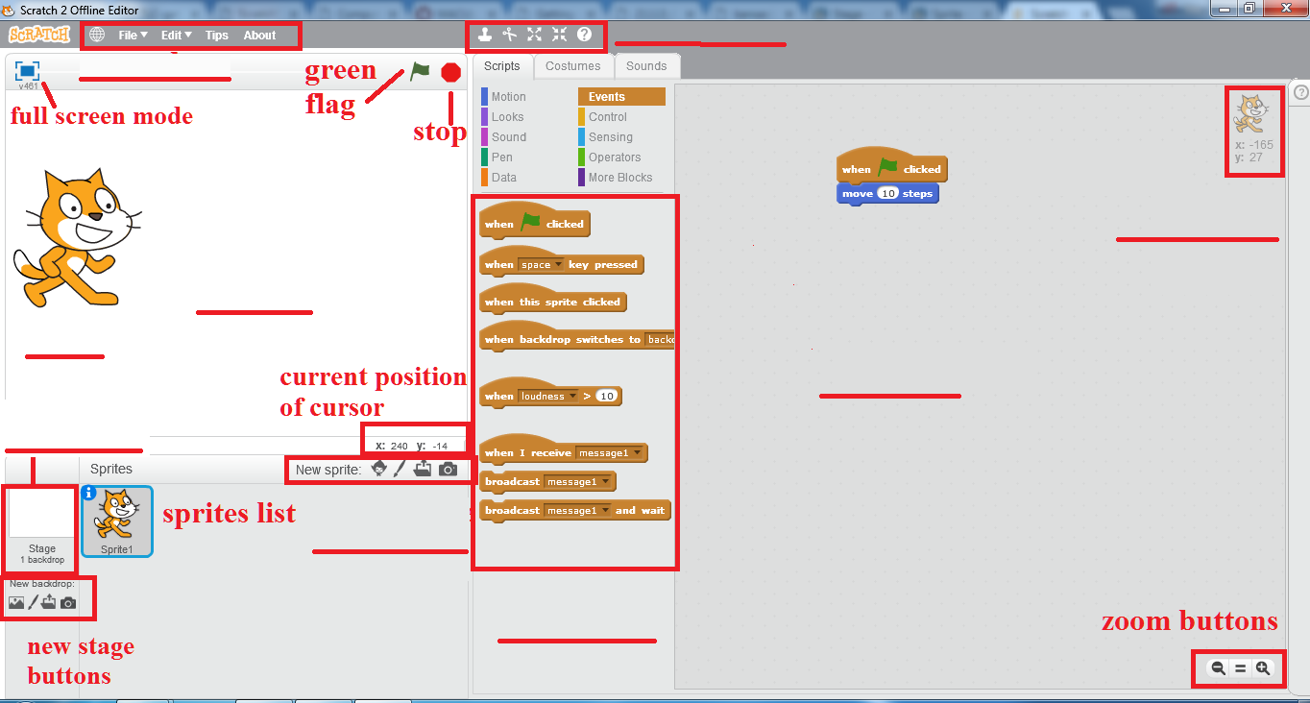

**Lab Activity 1**

1. Click on “Stage Backdrop”.
2. Click on “Backdrops” tab
3. Click on “Choose form Library” and select a picture of your choice.
4. Click on “OK”.
5. Your stage is ready. Repeat these to get more stages.

**Lab Activity 2**

1. Click on the Giga button to open sprite library
2. On the left side of window, under *Category,* click on *Animals*
3. Select sprite *Bear 2* from the sprite list

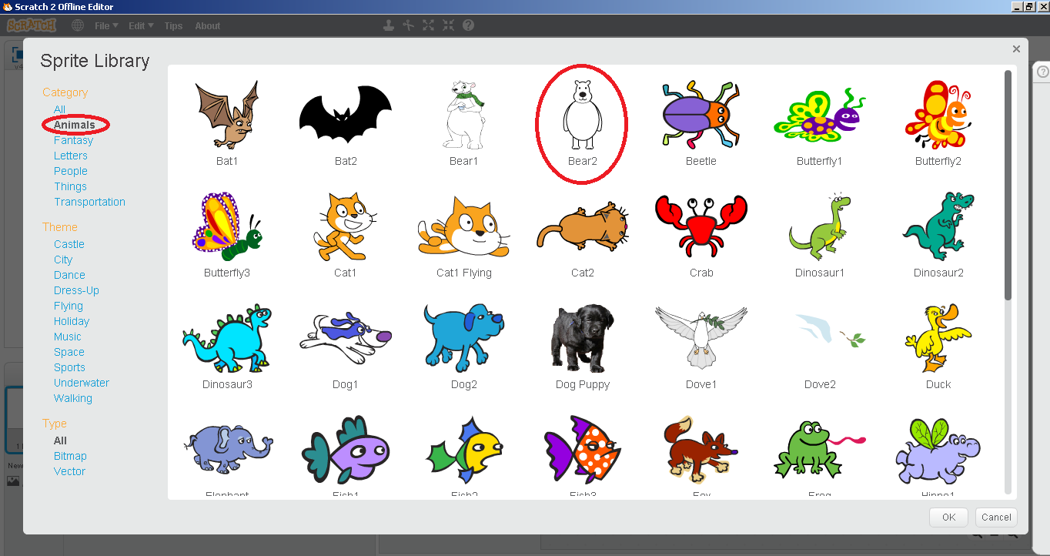

1. Click *ok*
2. Click on *Costumes*
3. Select the other costume available *bear 2-b*
4. From the tool bar on right side of paint editor, select the *fill with color* tool
5. From the color box at the bottom of screen, select color of your choice and fill the sprite bear with that color.

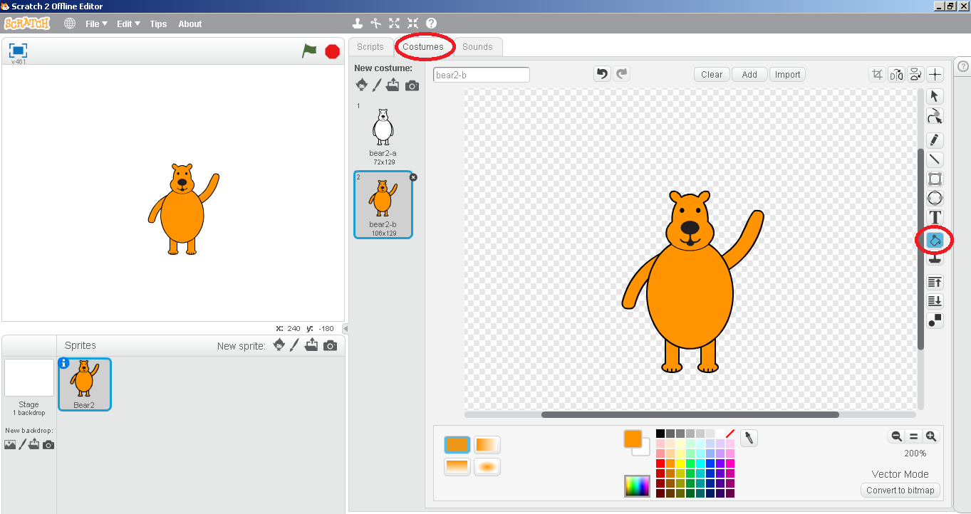

**Lab Activity 3**

1. Click on *paint new sprite* button in the *New Sprite* area
2. Scratch paint editor will open up
3. Draw a robot sprite using the rectangle, ellipse and line tools on the left side of the editor window and fill it with your desired colors using the *fill with color* tool

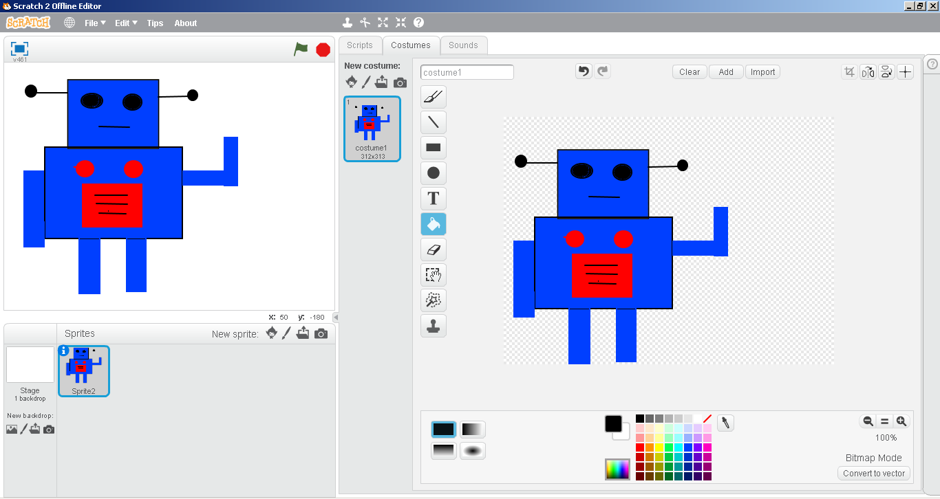

**Lab Activity 4**

1. Open sprite library by clicking on Giga button
2. Select *people* under category
3. Select sprite *Calvrett*

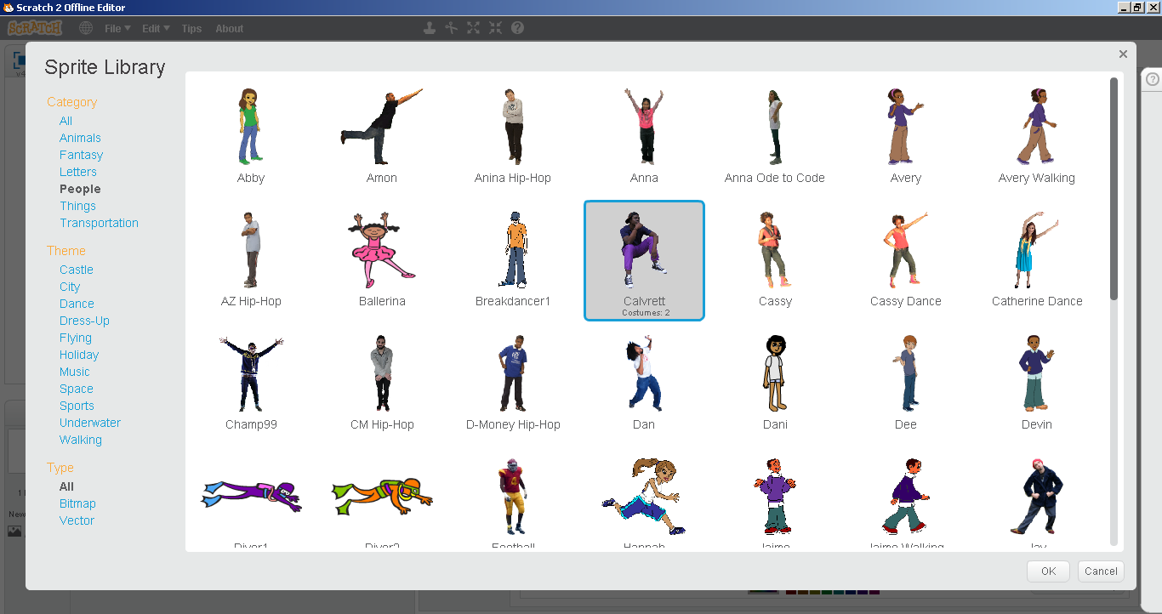

1. Select *Events* under *scripts*
2. Click and drag the *hat block * to the scripts area
3. Select *Looks* under *Scripts*
4. Click and drag  block to the scripts area
5. Place cursor at the area where *Hmm…* is written and click. *Hmm* will be highlighted
6. Write “*What should I eat today…”* instead of *Hmm… 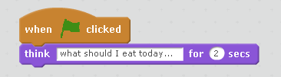*
7. Click on the green flag to play the script

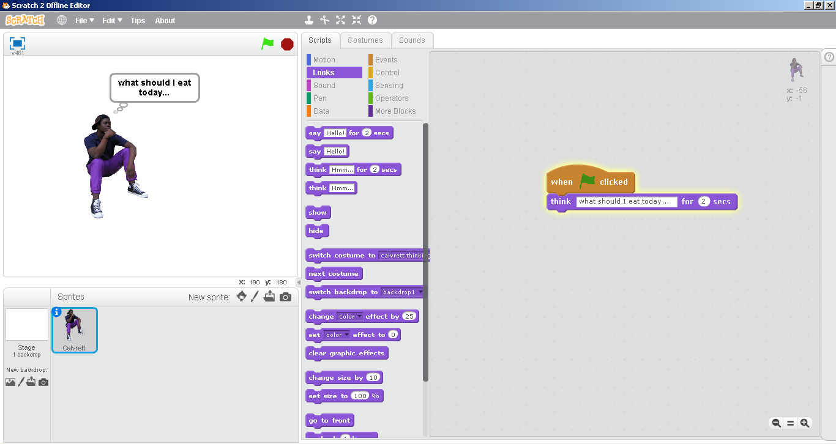

**Lab Activity 5**

**(A)**

1. Click on the Giga button to open sprite library
2. Under *Category* select *transportation*
3. Select any car of your choice and click ok.

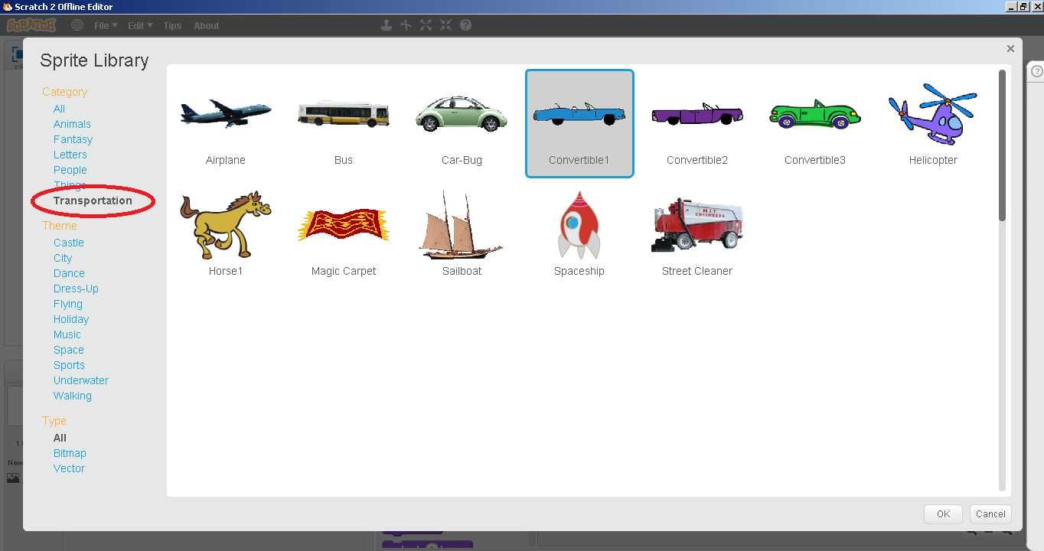

1. Click on *Stage backdrop*
2. Select *Backdrops*
3. Open backdrops library by clicking on the *choose backdrop from library* button

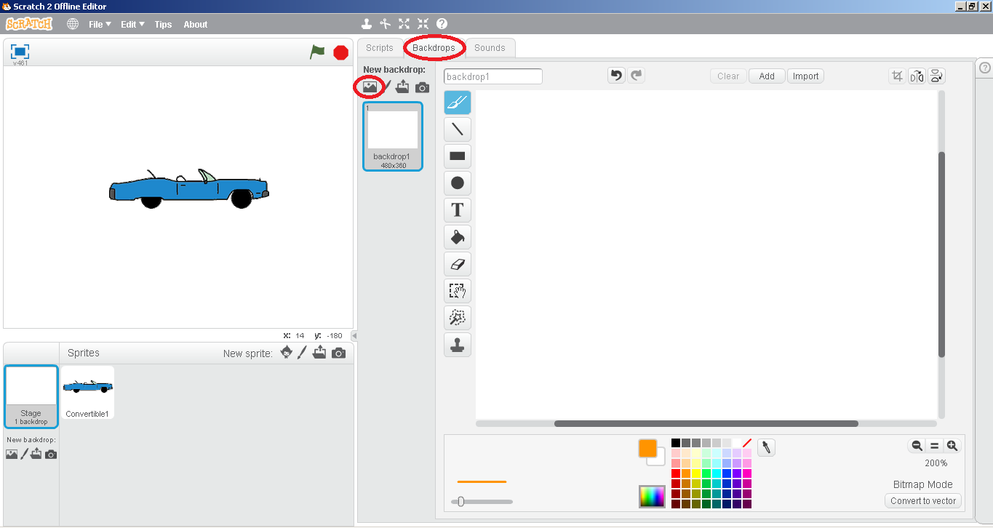

1. Under *Themes* select *City.*
2. Select *night city with street* and click *OK*
3. Click and drag the car sprite to the start of the road

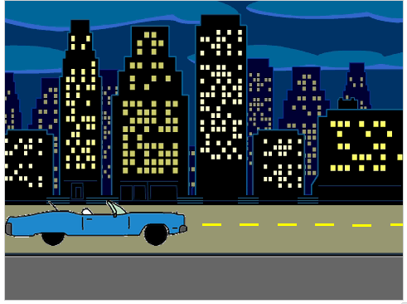

1. Open scripts area for sprite car
2. Click and drag the hat block from *Events*
3. Click and drag the  block from *Motion* to the scripts area
4. Attach both blocks together and click on the green flag

**(B)**

1. Select *Control* under *scripts*
2. Click and drag 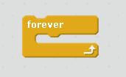 block to the scripts area and place the motion block inside it.

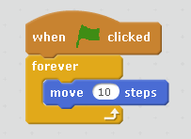

1. Now again click on the green flag button

**Lab Activity 6**

**(A)**

1. Open *Backdrops library*
2. Select *Castle* under *Themes*
3. Select backdrop *castle1* from the backdrops list

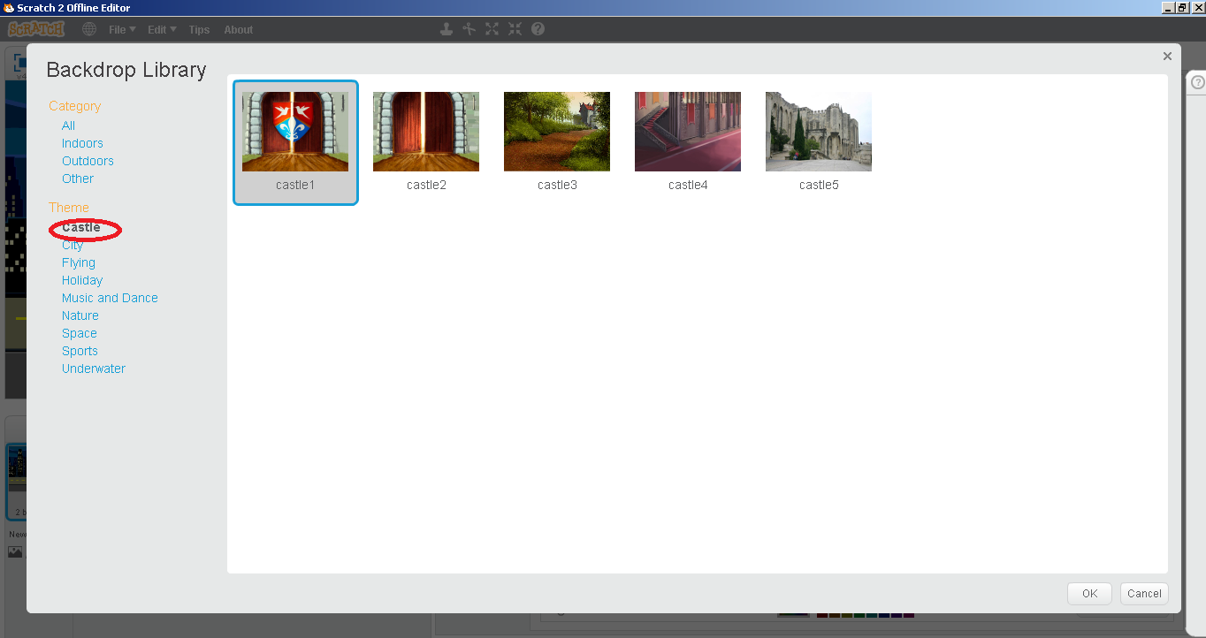

1. Click on Giga button to open sprites library
2. Select *Fantasy* under *Category*
3. Select sprite *Wizard* and click OK

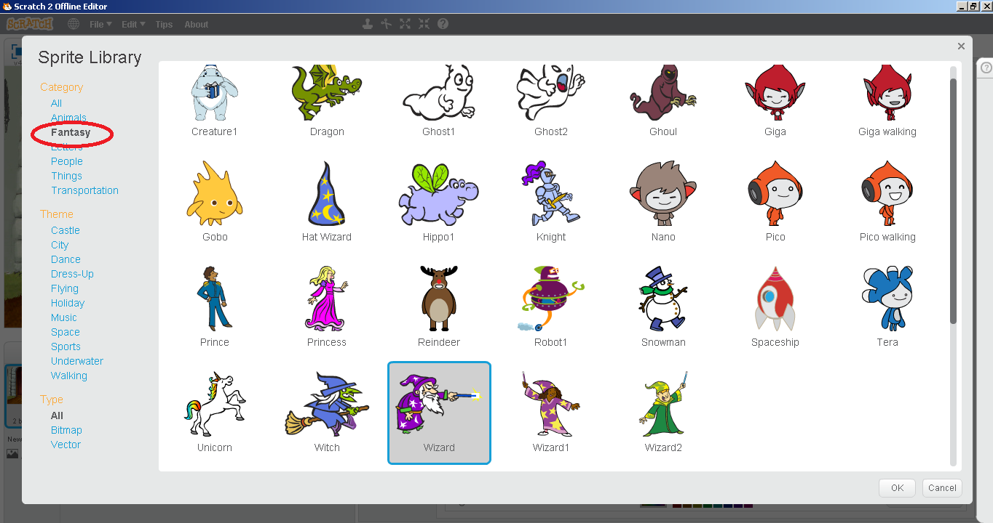

1. Again repeat the above steps and select sprite *Wizard 1*

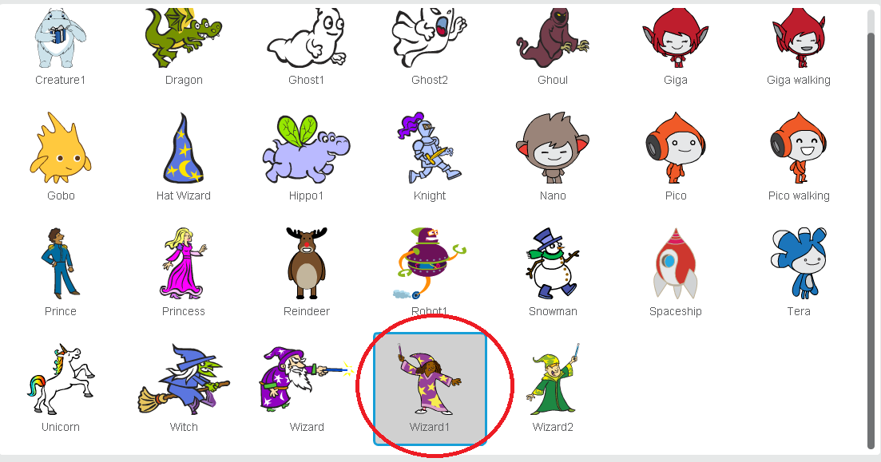

1. Place both sprites at opposite sides of the stage
2. Change the direction of sprite *Wizard 1* by using the *Flip left-right* button

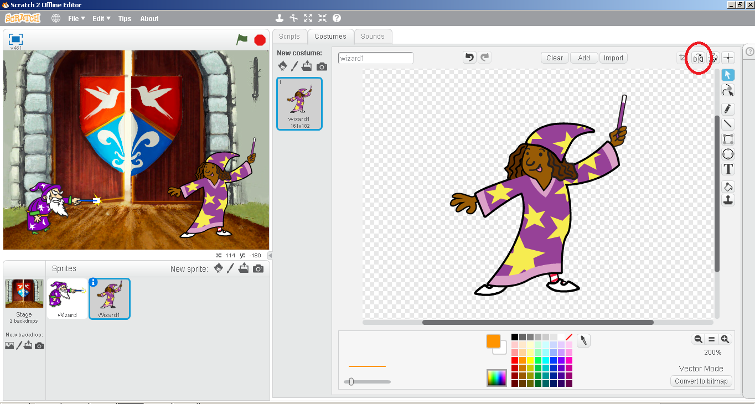

1. Select sprite *Wizard* from the sprites list
2. Click and drag the *hat block* under scripts from Events to the *scripts area*
3. Click and drag  block to the *scripts area*
4. Attach both blocks
5. Edit and write *”Abra Cadabra!”* in place of *Hello!*
6. Click on green flag button

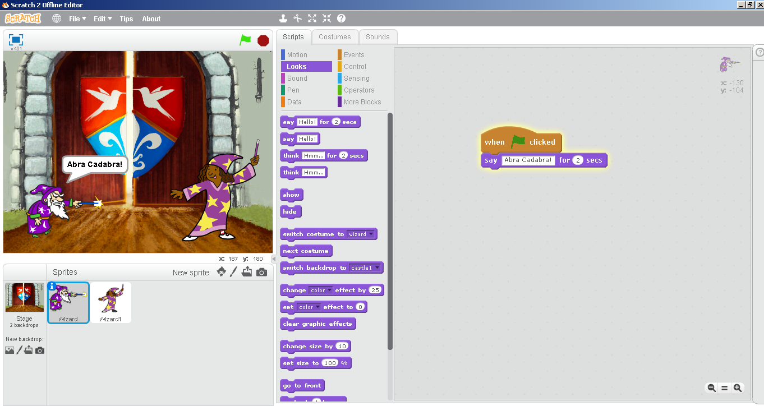

**(B)**

1. Now click on the thumbnail of sprite *Wizard 1* in the *sprite list*
2. Click and drag the *hat block* from *Events*
3. Click and drag  block from *Control*
4. Edit and write 2 instead of 1 in the wait block
5. Click and drag  block from *Looks* to the scripts area
6. Edit and write *“NOOO!!!”* instead of *Hello!*
7. Attach all three blocks together

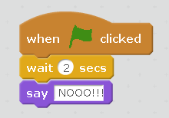

1. Click on the green flag button